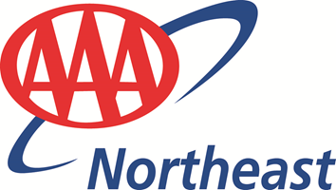
FOR IMMEDIATE RELEASE May 18, 2020
Mary Maguire, Director, Public and Legislative Affairs
(401) 865-9414
Follow us on Twitter @AAANortheast

AAA REOPENING SELECT MASSACHUSETTS OFFICES TODAY; RMV SERVICES AVAILABLE TO MEMBERS BY APPOINTMENT ONLY
AAA Northeast is reopening select branch offices in Massachusetts today, while following strict social distancing procedures and CDC guidelines for the protection and benefit of employees and AAA members. Members should visit aaa.com/branches and enter their zip code to find the nearest open office. Everyone will be required to wear a face covering to enter and conduct business at AAA branch offices, and will be asked to socially distance. There will be a strict limit on the number of members allowed in AAA branches at any given time.
Massachusetts Registry of Motor Vehicles services will be available by appointment only to members who complete an online reservation ahead of their visit, and members can schedule appointments up to two weeks in advance. AAA membership, insurance, travel and financial services will be available, either in person or through a virtual meeting. In some cases, curbside service will be available. Due to staffing issues, some branches may remain closed or close on certain days, so members are urged to check the web site at aaa.com/branches or call the branch prior to visiting.
“In strict adherence to the Governor’s guidance, we are pleased to be reopening Massachusetts offices with the goal of helping and serving during this challenging time,” said John Galvin, AAA Northeast President and CEO. “We’re also eager to resume Registry services, though they will be by appointment only for the foreseeable future,” he added.
Office hours will be Monday-Friday from 9 a.m. to 5 p.m., and Saturdays from 9 a.m. to 1 p.m. To make an RMV appointment, visit aaa.com/appointments.
AAA’s 24-hour Emergency Roadside Assistance has been and continues to be available throughout the entirety of the COVID-19 shutdown.
AAA Northeast is a not-for-profit auto club with 62 offices in Rhode Island, Massachusetts, Connecticut, New Jersey, New Hampshire and New York, providing more than 5.7 million local AAA members with travel, insurance, finance, and auto-related services.

